14.56: a) The volume displaced must be that which has the same weight and mass as the ice,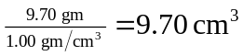(note that the choice of the form for the density of water avoids conversion of units). b) No; when melted, it is as if the volume displaced by the 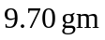 of melted ice displaces the same volume, and the water level does not change. c) 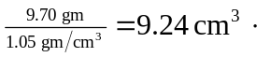 d) The melted water takes up more volume than the salt water displaced, and so 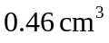 flows over. A way of considering this situation (as a thought experiment only) is that the less dense water “floats” on the salt water, and as there is insufficient volume to contain the melted ice, some spills over.

